Test Case: tc002_SPX_Dev5_Crear_Requisicion_Spot_Tipo_Cobro_Project
Step 1 - Enter username and password and click to button Enter: Credentials Entered
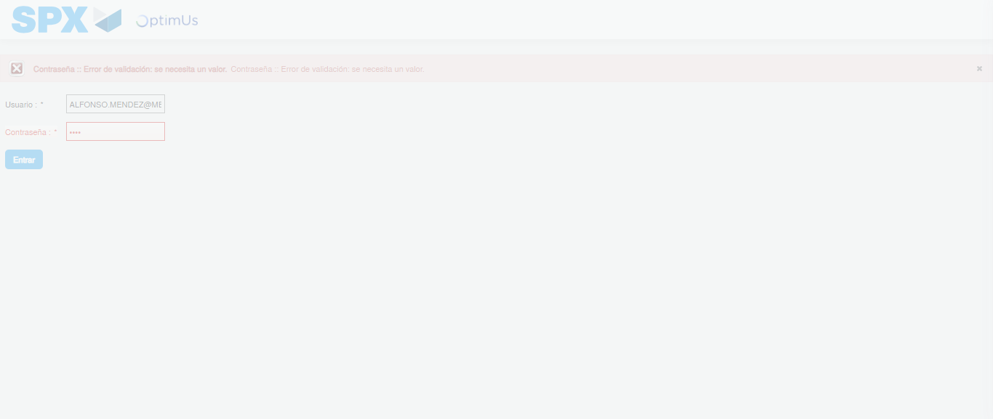Image file-name: QC_Testing-tc002_SPX_Dev5_Crear_Requisicion_Spot_Tipo_Cobro_Project-1783381542559

Step 2 - Select to UEN and Access to Spot Buy Requisitions : UEN Correctly selected and Correct access
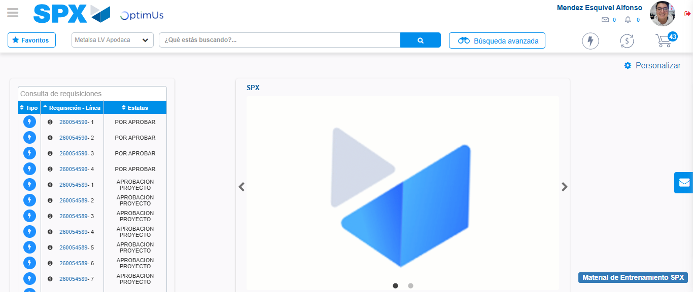Image file-name: QC_Testing-tc002_SPX_Dev5_Crear_Requisicion_Spot_Tipo_Cobro_Project-1783381567620

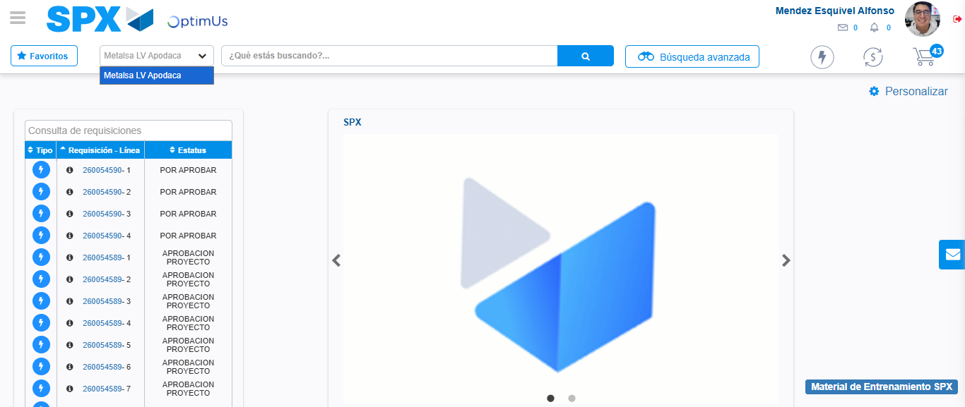Image file-name: QC_Testing-tc002_SPX_Dev5_Crear_Requisicion_Spot_Tipo_Cobro_Project-1783381570106

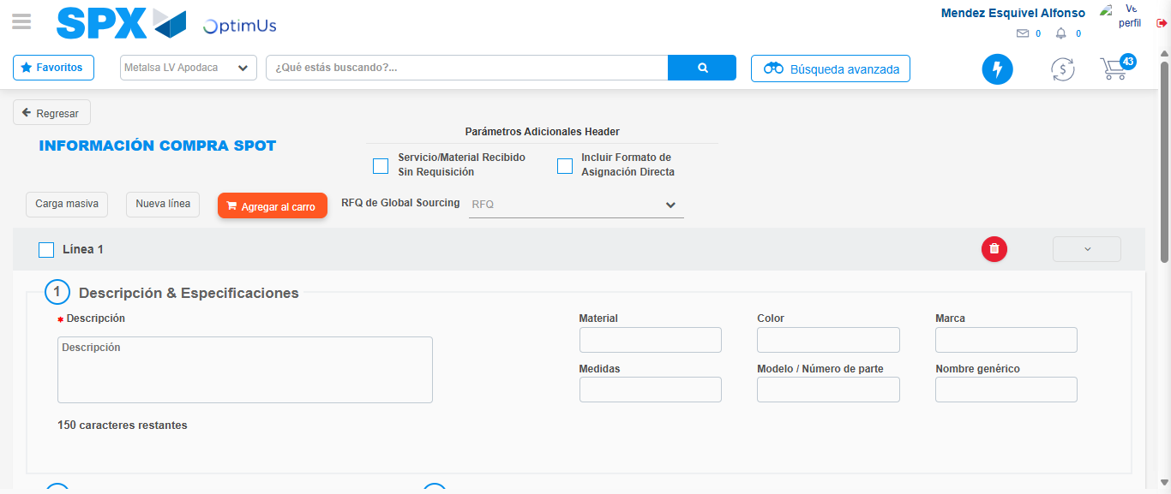Image file-name: QC_Testing-tc002_SPX_Dev5_Crear_Requisicion_Spot_Tipo_Cobro_Project-1783381591948

Step 3 - Data Capture Spot Buy Requisition: Data captured correctly
Image file-name: QC_Testing-tc002_SPX_Dev5_Crear_Requisicion_Spot_Tipo_Cobro_Project-1783381592169

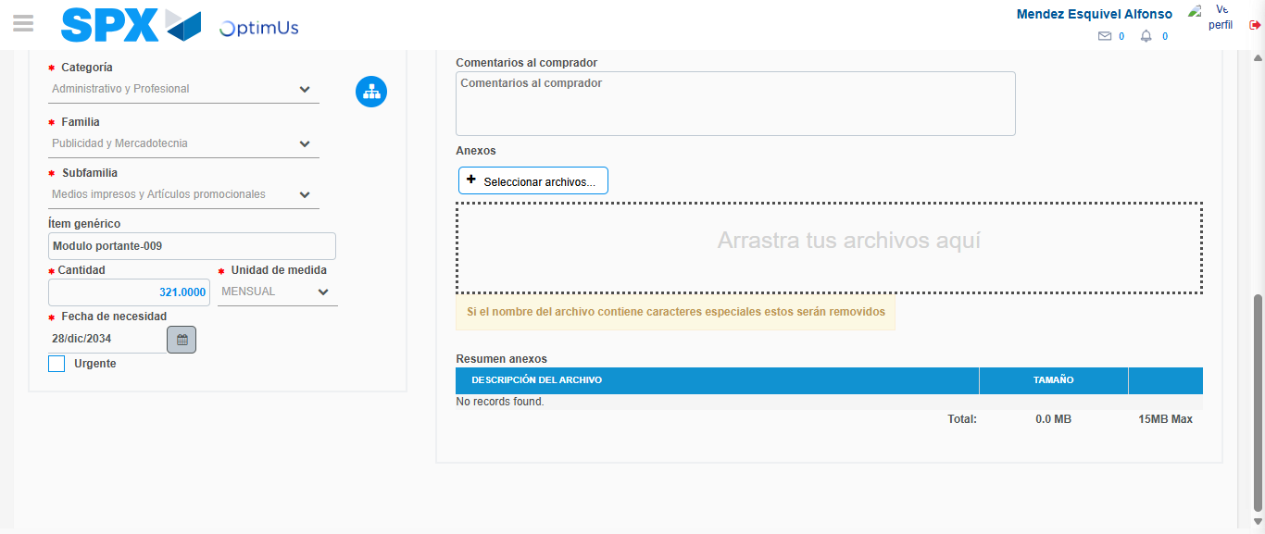Image file-name: QC_Testing-tc002_SPX_Dev5_Crear_Requisicion_Spot_Tipo_Cobro_Project-1783381602732

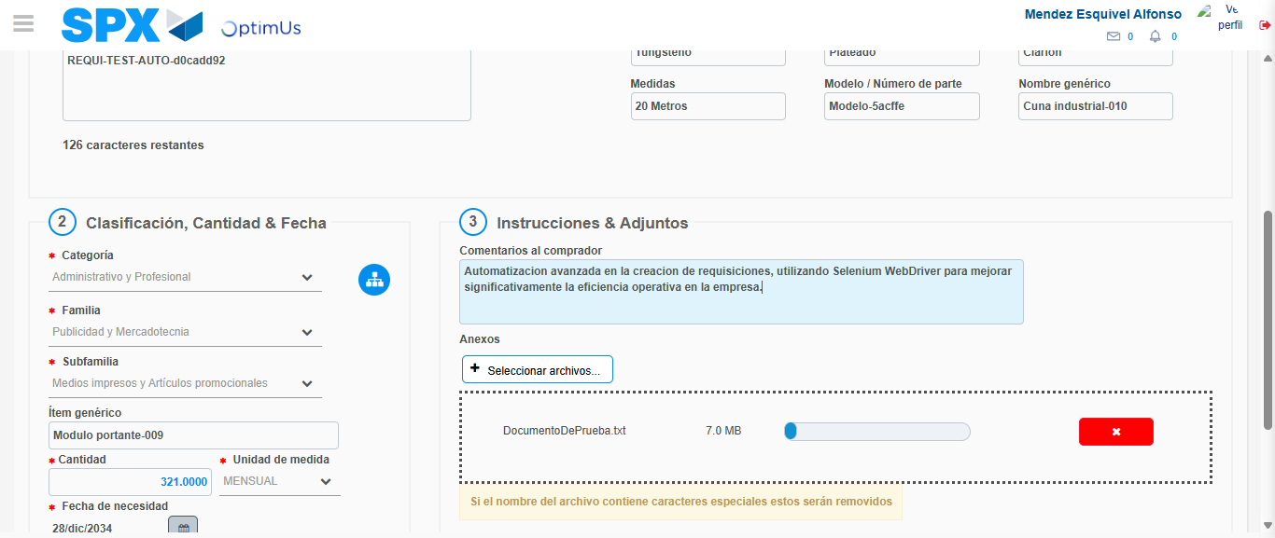Image file-name: QC_Testing-tc002_SPX_Dev5_Crear_Requisicion_Spot_Tipo_Cobro_Project-1783381603493

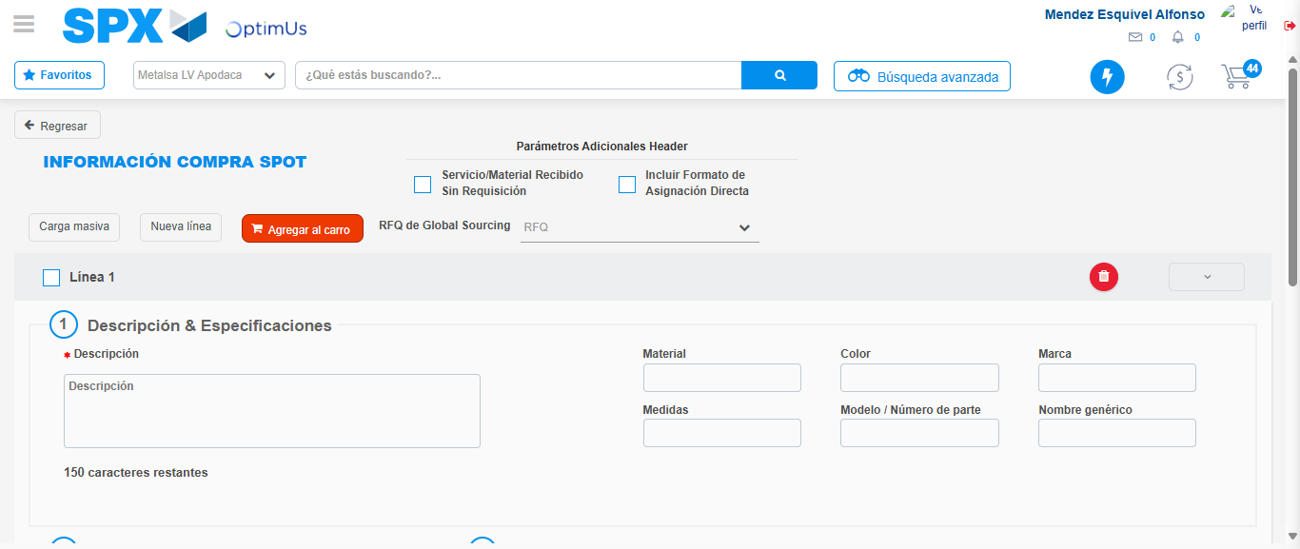Image file-name: QC_Testing-tc002_SPX_Dev5_Crear_Requisicion_Spot_Tipo_Cobro_Project-1783381610905

Step 7 - Return to Main Page SPX : Return to Main Page SPX
Image file-name: QC_Testing-tc002_SPX_Dev5_Crear_Requisicion_Spot_Tipo_Cobro_Project-1783381567620

Image file-name: QC_Testing-tc002_SPX_Dev5_Crear_Requisicion_Spot_Tipo_Cobro_Project-1783381570106

Image file-name: QC_Testing-tc002_SPX_Dev5_Crear_Requisicion_Spot_Tipo_Cobro_Project-1783381591948

Image file-name: QC_Testing-tc002_SPX_Dev5_Crear_Requisicion_Spot_Tipo_Cobro_Project-1783381613143

Image file-name: QC_Testing-tc002_SPX_Dev5_Crear_Requisicion_Spot_Tipo_Cobro_Project-1783381613293

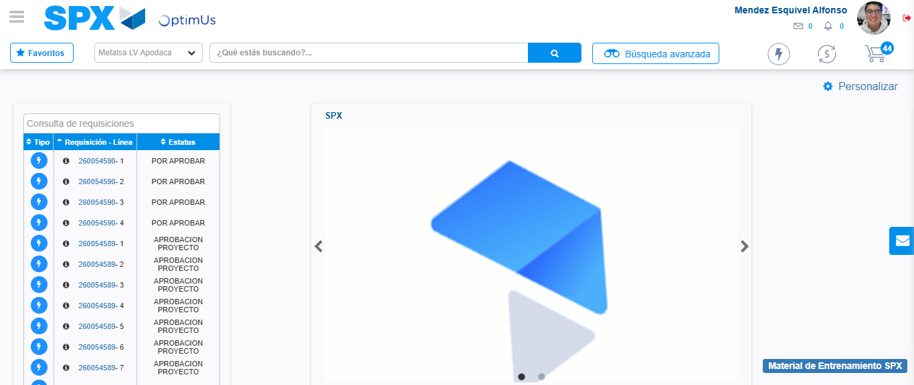Image file-name: QC_Testing-tc002_SPX_Dev5_Crear_Requisicion_Spot_Tipo_Cobro_Project-1783381634567

Step 8 - Log Out : Log Out SPX
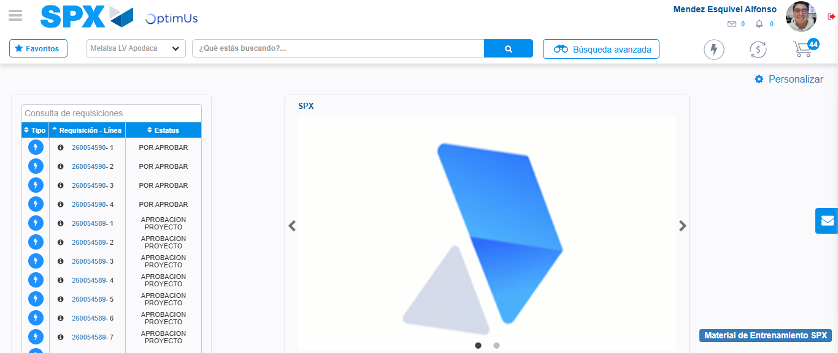Image file-name: QC_Testing-tc002_SPX_Dev5_Crear_Requisicion_Spot_Tipo_Cobro_Project-1783381634830

